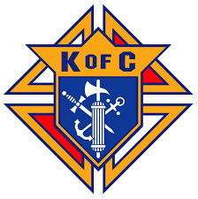
The KC’s of Ascension and St. Bernards will be hosting their annual Fish Fry on March 7th!

With the money raised, we have been able to support both parishes by offering assistance to Faith Formation, the quilting group, the scholarship fund, and other parish projects.
This year we are again reaching out for your support, through volunteering, attending the Fish Fry, and your prayers for a successful event.
We have volunteer opportunities on Thursday morning, Thursday evening, and all day of the Fish Fry.
You can sign up to volunteer either by scanning the QR code for Sign up Genius, or by calling Jeremy Gesinger, 952-212-2369
We would also appreciate donations of cookies to serve with the meal at the Fish Fry. Please bring cookies to the Ascension church kitchen during the week of the Fish Fry. (some cookies are needed by Wednesday to pack for takeout/drive through meals). Please contact Tim George, 763-639-0992.

Your help is greatly appreciated and enables our Fish Fry to be a huge success ! Thank you!

